American University of Beirut

Critical Review
Where We Come From by Emily Jacir

Name: Freddy Vartabedian
Instructor: Dr. Angela Harutyunyan

Date: April 6, 2012

Where We Come From by Emily Jacir

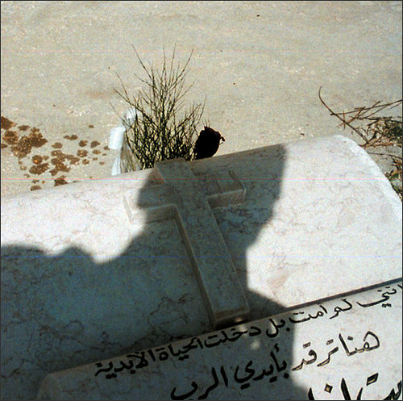

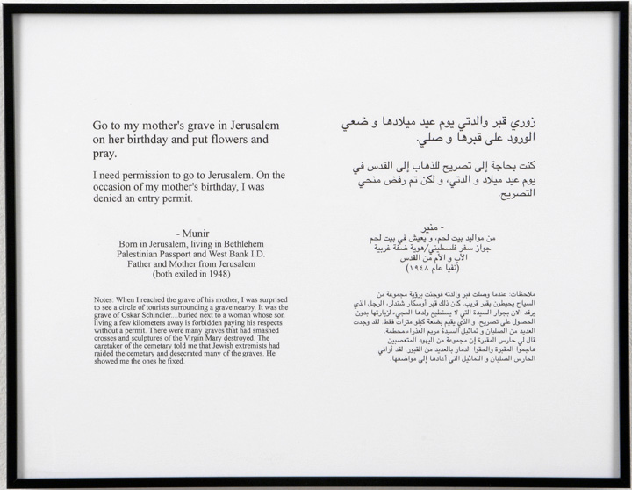

“Go to my mother’s grave in Jerusalem on her birthday and put flowers and pray.” These are the words of Munir, a Palestinian living in West Bank, written in English and Arabic, requesting Emily Jacir to perform a task that would seem more than ordinary for most people around the world, yet impossible for Palestinians, exiles in their own land. Munir’s request is followed by a poignant note by Jacir describing her visit and observations of the grave and the partly wrecked graveyard, indicating her accomplishment of Munir’s request and hinting at the Palestinian/Israeli conflict. The text in black print, standing out on a white background and framed in black is accompanied by the colored, but unframed picture of a grave with Jacir’s ghostlike shadow over the Arabic inscriptions on the tombstone, and showing flowers on one side. The text and the picture combine to form a poetic element of a happy moment and a sad reality, the reality of Munir and the reality of every Palestinian.¹
The work described is one of the many comprising Emily Jacir’s project Where We Come From which itself is a series of photo-text presentations that includes 30 texts, 32 photos and a video². The content being ordinary activities ranging from eating a local dish to even paying a phone bill, all being attempts of fulfilling the requests of exiled Palestinians painfully deprived of the freedom of mobility in their homeland, makes her work a peaceful and truthful narrative that touches the viewer’s soul while raising the complex political issue in its social and human dimensions. “If I could do anything for you, anywhere in Palestine, what would it be?”³ was the question Jacir posed and tried to answer and the outcome was her work, Where We Come From. Like a caring mother who couldn’t stand and watch her children suffering, and taking advantage of her American passport, she tried to fulfill the wishes of fellow Palestinians; a gesture of sympathy that brought art and life together and put her on the path of international fame.
Emily Jacir, a conceptual Palestinian artist, who has won the Venice Bienniale’s award, the Prince Clause award and the Hugo Boss prize from Guggenheim, and whose work is exhibited worldwide, lives between New York and Ramallah and considers her work as an outcome of her life experiences⁴. In her work Where We Come From, where she addresses the themes of identity, exile and Palestinian rights, the content and the context, though simple, intersect and merge in complexity to create a contrast between a sweet dream and a bitter reality. As Steve Sabella explains, the use of a linguistic text serves the purpose of directing the viewer’s focus to Jacir’s purpose, while the shift between text and picture emphasizes the impossibility of such a connection in reality⁵. T. J. Demos describes the use of pictures “as a stand-in for a realization of a yearned for desire.” He goes on to say, “The photograph is a cold and unsatisfying substitute. But cruelly it is the only one to be had,”⁶ confirming Jacir’s point of view that the dreams of those Palestinians only actualize through her lense. Moreover, the contrast between the innocent wish and painful reality is further conveyed through the frames of the texts implying restrictions and borders, whereas the unframed pictures convey the boundless possibility of such wishes only in fantasy.⁵
Through the use of truthful material and through combining personal voices into a collective bilingual voice, Jacir’s conceptual work, Where We Come From, which seems political in the first place, transcends its political and even its emotional core to arrive at a highly humanely charged product that is capable of engaging not only Palestinian and Arab audiences, but also a wider variety of audiences, only to open their eyes to view the Palestinian citizen as a human.

References (in order of occurrence in the review):

1-Nafas art magazine,
http://universes-in-universe.org/eng/nafas/articles/2003/emily_jacir/photos/01_jacir

2-Nafas art magazine, Oct 2003,
http://universes-in-universe.org/eng/nafas/articles/2003/emily_jacir

3-Kaelen Wilson-Goldie, Her Dark Materials, The National, Jul13,2008 http://imeu.net/news/article0013613.shtml,

4-Michael Z. Wise, Border Crossings Between Art and Life, The New York Times, Feb1,2009
http://www.nytimes.com/2009/02/01/arts/design/01wise.html?_r=3&sq=emily%20jacir&st=cse&scp=3&pagewanted=all

5-S. Sabella, Palestinian Conceptual Art, http://stevesabella.com/Palestinian%20Conceptual%20Art.pdf

6-T. J. Demos, Desire in Diaspora: Emily Jacir,
http://www.ucl.ac.uk/art-history/about_us/academic_staff/dr_tj_demos/further_publication

